1. Assume that the following activated table exists. It contains one record.

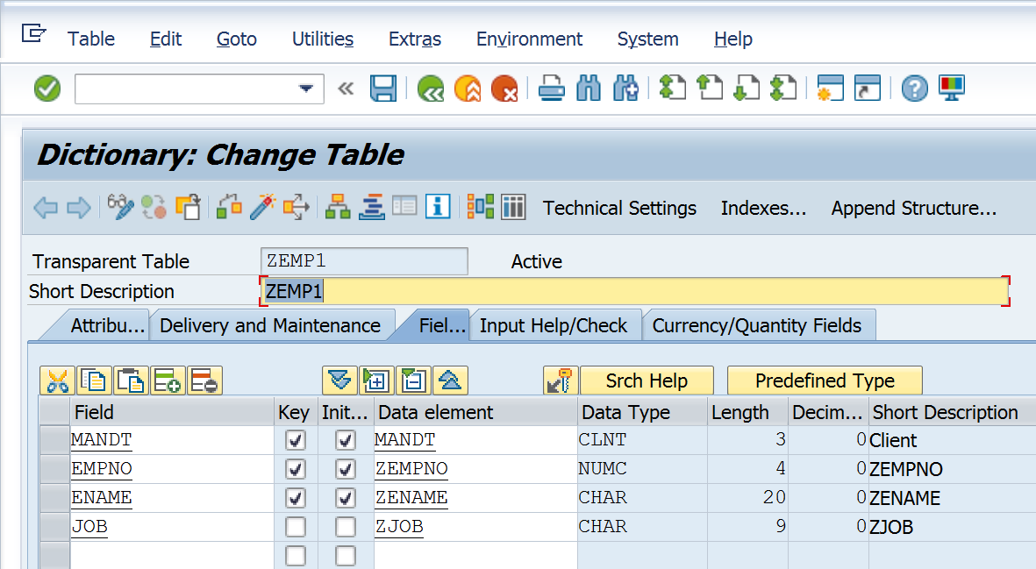

1. There is a need to change the primary key of the table. E.g. Ename should not be a part of primary key. Uncheck the checkbox for primary key for the field Ename. Check the table.

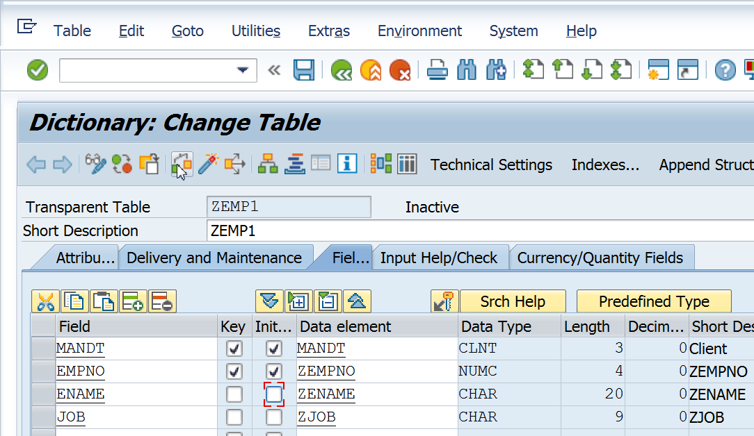

1. An error will be shown as below. This error will also be seen if the table is activated.

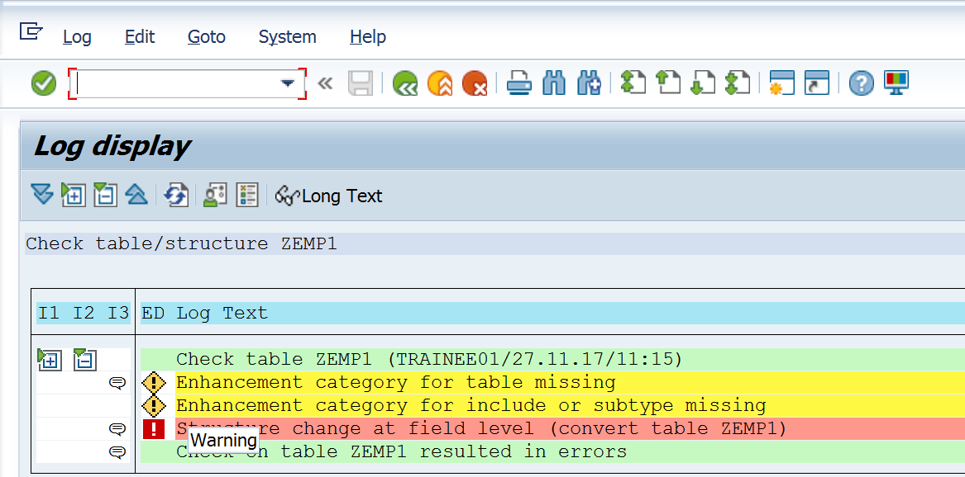

1. To make changes, follow these steps. These steps can also be executed by going to SE14.

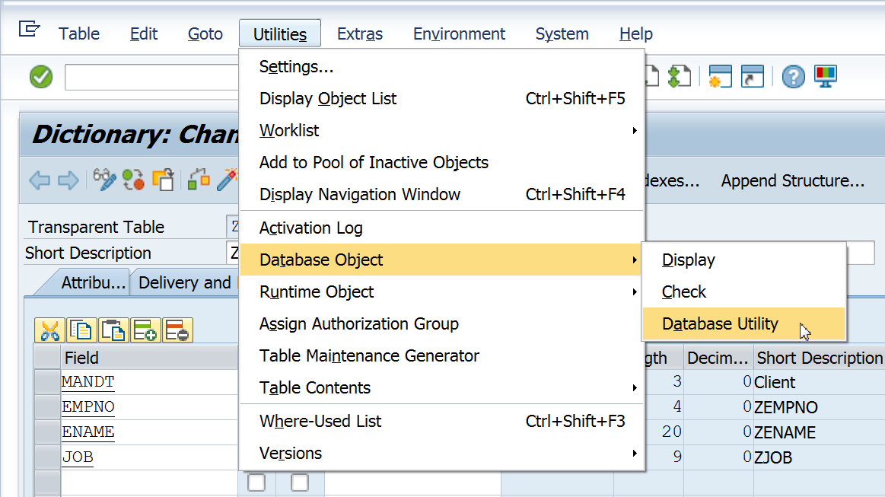

1. Click on Activate and Adjust.

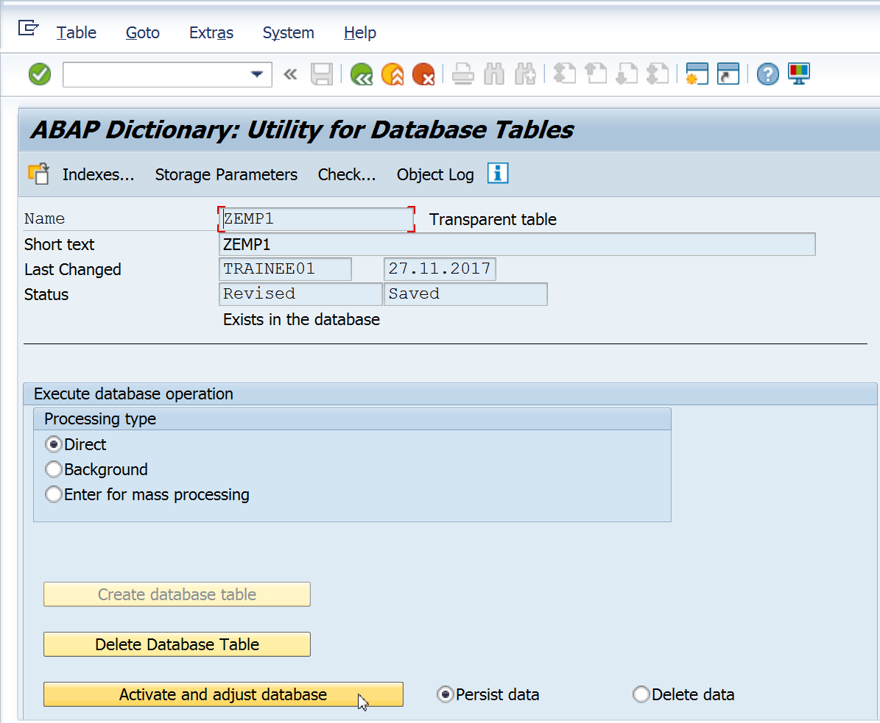

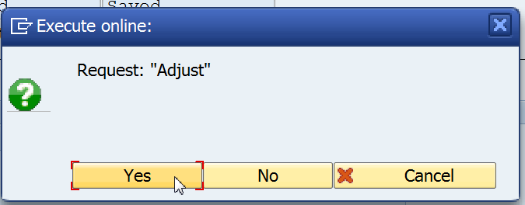

1. See the message at status bar. Click on the back button.

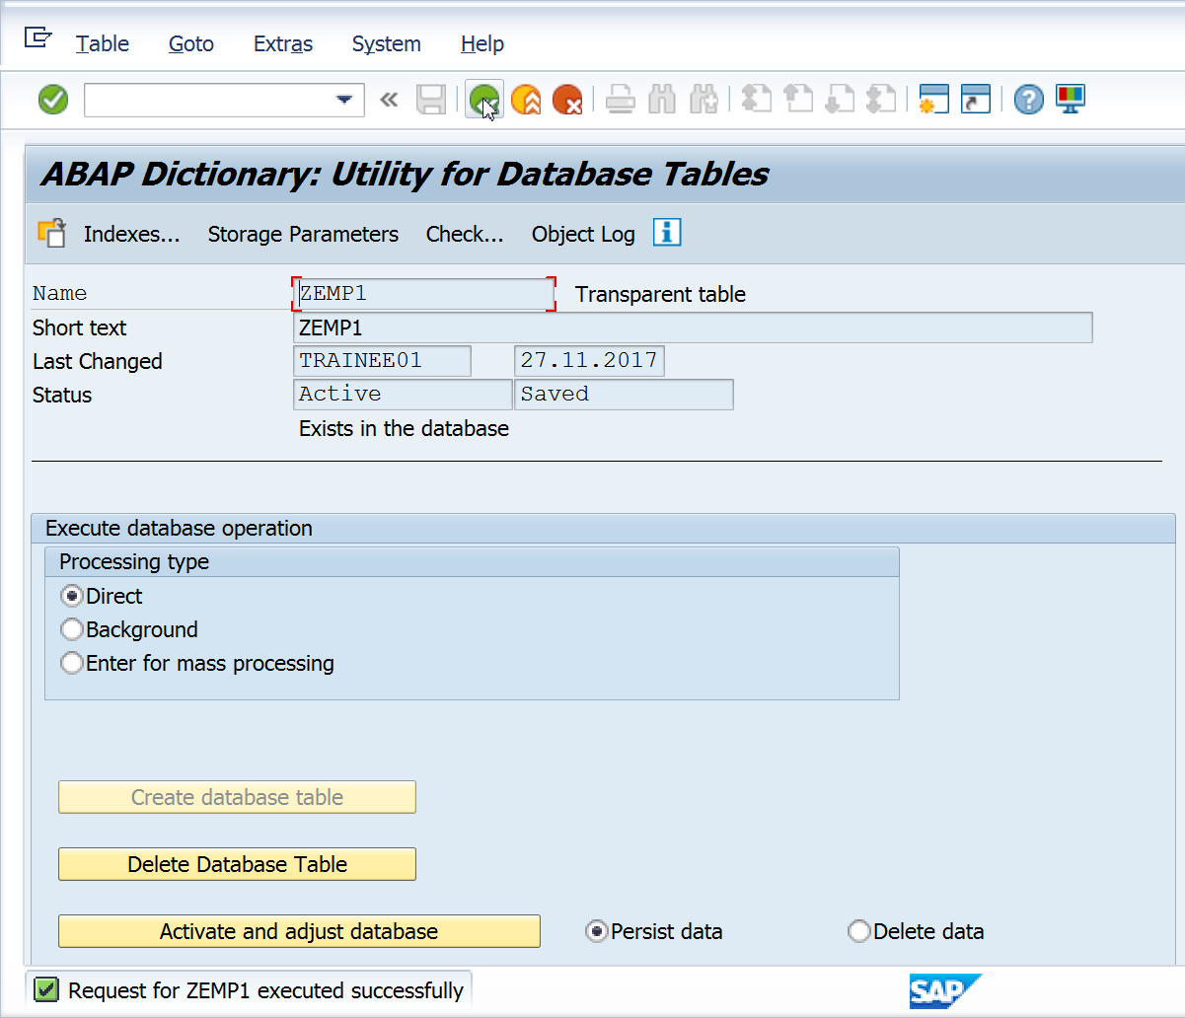

1. Now, activate the table. The table gets activated.

